

CS-25-304 and SON Researchers

Final Design Report

Prepared for

Lana Sargent

Dr. Jered Wendte

Dr. Rachel Regal

VCU School of Nursing

By

William Meredith  
Alex Davidkov  
Haley Vivian  
Edson Decker

Under the supervision of

John Leonard

Date  
5/9/2025

**Executive Summary**

The Mobile Health and Wellness Program (MHWP) at Virginia Commonwealth University (VCU) is dedicated to addressing health disparities in underrepresented populations through data-driven research. However, the program faces challenges in efficiently organizing and filtering the extensive data collected via the RedCap system, which hinders participant recruitment and delays critical health studies. This project aims to develop a streamlined solution, including a prototype API and user-friendly application, to optimize data retrieval and participant identification for MHWP researchers.

This semester, the team focused on final developments for the project based on the previous semester’s design and workflow development. Key accomplishments include:

* Implementation of the Front-end based on the Figma designs developed in the previous semester.
* Building core-user flows in participant search, multi-criteria filtering, and results display dashboards.
* Writing Docker configurations to package the MVP in a containerized deployment environment.

These deliverables demonstrate the feasibility of our designs in a live environment, provide MHWP with an immediately usable tool for participant identification, and lay a solid foundation for full-stack development. By delivering a dockerized front-end that directly connects to the backend prototype, we have accelerated the path toward a production-ready system—advancing MHWP’s mission to streamline research workflows and improve health outcomes in underserved communities.

The outcomes of this project have the potential to revolutionize how data is managed in community health research programs, serving as a model for similar initiatives and advancing the field of healthcare informatics.

**Table of Contents**

Section A. Problem Statement 5

Section B. Engineering Design Requirements 7

B.1 Project Goals (i.e. Client Needs) 7

B.2 Design Objectives 7

B.3 Design Specifications and Constraints 8

B.4 Codes and Standards 9

Section C. Scope of Work 11

C.1 Deliverables 11

C.2 Milestones 12

C.3 Resources 12

Section D. Concept Generation 13

Section E. Concept Evaluation and Selection 14

Section F. Design Methodology 16

F.1 Computational Methods (e.g. FEA or CFD Modeling, example sub-section) 16

F.2 Experimental Methods (example subsection) 16

F.5 Validation Procedure 16

Section G. Results and Design Details 18

G.1 Modeling Results (example subsection) 18

G.2 Experimental Results (example subsection) 18

G.3 Prototyping and Testing Results (example subsection) 18

G.4. Final Design Details/Specifications (example subsection) 18

Section H. Societal Impacts of Design 20

H.1 Public Health, Safety, and Welfare 20

H.2 Societal Impacts 20

H.3 Political/Regulatory Impacts 20

H.4. Economic Impacts 20

H.5 Environmental Impacts 21

H.6 Global Impacts 21

H.7. Ethical Considerations 21

Section I. Cost Analysis 22

Section J. Conclusions and Recommendations 23

Appendix 1: Project Timeline 24

Appendix 2: Team Contract (i.e. Team Organization) 25

Appendix 3: [Insert Appendix Title] 26

References 27

### Section A. Problem Statement

The Mobile Health and Wellness Program (MHWP) at VCU serves underrepresented populations in Richmond, collecting extensive data through the RedCap system, including demographics, test results, and surveys. However, researchers face difficulties in efficiently organizing and filtering this data to find participants meeting specific criteria, delaying health studies and hindering research success.

The problem affects MHWP researchers who must sift through large datasets to find participants with specific health attributes or demographics. This issue is common in research programs using large-scale data but lacking efficient tools for data visualization, participant identification, and recruitment. In healthcare research, timely recruitment is critical to the success of studies and interventions. Delays in this process can increase costs, slow research, and miss opportunities to improve health outcomes for the patient.

The project client is the MHWP research team at VCU health, and the primary stakeholders include researchers, clinicians, and the participating communities. These stakeholders rely on accurate, timely data to address critical health disparities and ensure that research efforts are meaningful and actionable. The unmet need is for a solution that will enable researchers to quickly and easily access and filter participant data based on specific criteria, such as test results, demographic information, and health trends.

This project falls under the field of health informatics and research data management. It seeks to advance current technologies by developing a prototype API and an application that can pull data from the RedCap system and allow for more streamlined participant selection. Existing tools, such as basic database querying systems, do not provide the level of customization and specificity required for MHWP researchers. Although past attempts to address similar problems have focused on creating generalized data visualization and search tools, these systems are not tailored to the specific needs of community-based health research programs like MHWP.

This project enhances existing technologies by introducing advanced data filtering and a user-friendly interface tailored to MHWP’s needs. It will improve participant recruitment, speed up research, and contribute to better health outcomes for underserved communities. By improving data handling, the project can also serve as a model for other health research programs, advancing the field of healthcare informatics.

In conclusion, this project seeks to address a crucial gap in healthcare research by developing a system that optimizes data retrieval and participant identification. It will build upon existing methods while introducing novel features tailored to the needs of MHWP researchers, ensuring that health studies can proceed efficiently and effectively.

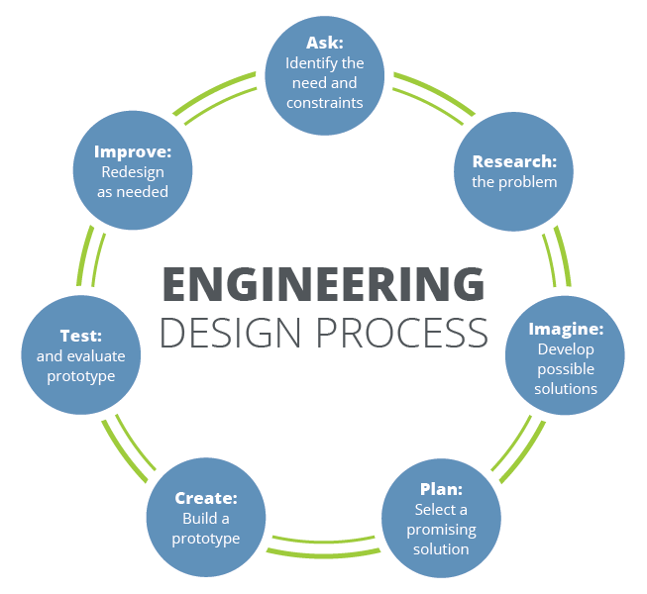

**Figure 1. The iterative nature of the engineering design process [2].**

### Section B. Engineering Design Requirements

This section describes the goals and objectives of the project, as well as all **realistic constraints** to which the design is bound. It is meant to provide a structure that helps to formulate the problem. Design requirements are often derived from client or stakeholder needs. They may consider benchmarking against or improving on currently available solutions, providing novel techniques or design solutions, integration with existing components, systems, or equipment, required codes and standards, general observations of the problem space, etc. Describe how the requirements provided below were researched and decided upon. Common design requirements often include considerations of the design efficacy, cost, safety, reliability, usability, and risk, among others.

#### B.1 Project Goals (i.e. Client Needs)

The goal of this project, from the perspective of the MHWP researchers and stakeholders, is to develop a system that improves the process of participant identification and data analysis from large datasets collected through RedCap. Specifically, the system should enhance the ability of researchers to filter, analyze, and retrieve data efficiently, streamlining the recruitment process for health studies.

To produce an improved method for achieving some function

* To create a more efficient method for identifying participants who meet specific research criteria (e.g., demographics, health metrics) based on the data stored in the RedCap system.
* To design a tool that provides researchers with faster, more accurate access to critical data points, improving decision-making in the research process.
* To integrate the system with RedCap while ensuring it works as a website application, supporting both researchers and clinicians in field-based settings.
* To ensure the solution complies with all necessary data privacy and security standards, such as HIPAA, safeguarding participant information.

#### B.2 Design Objectives

* The design will provide **advanced filtering capabilities** for participant data, allowing researchers to quickly and efficiently identify individuals based on specific criteria such as demographics and health metrics.
* The design willensure **integration with the RedCap system**, allowing for real-time data retrieval and analysis, and presenting the data in an accessible format for research use.
* The design will ensure **data security and privacy**, adhering to all HIPAA compliance requirements, and protecting sensitive participant information.
* The design will be **user-friendly and intuitive**, allowing non-technical users, such as researchers and clinicians, to easily navigate and use the application in community-based settings.

#### B.3 Design Specifications and Constraints

The following design specifications and constraints outline the limitations, restrictions, and requirements that must be met for the project to be successful. These specifications are tied to the objectives and ensure the design fulfills its intended purpose. They are measurable, specific, and help assess whether the final design meets all required goals.

**Specifications:**

1. **Integration with RedCap (Functional Constraint):**

The design must seamlessly integrate with the existing RedCap system to retrieve and manage data without disruption.

2. **Tablet Compatibility (Hardware Constraint):**

The system must be compatible with both Android and iOS, ensuring smooth operation and performance on these platforms.

3. **User Interface Usability (Usability Constraint):**

The interface must be intuitive and user-friendly, allowing non-technical users, such as researchers and clinicians, to easily navigate the system without extensive training.

4. **Data Security and HIPAA Compliance (Legal/Policy Constraint):**

The design must meet HIPAA standards to protect sensitive participant data, ensuring encryption and secure access control.

5. **Performance (Efficiency Constraint):**

The system must efficiently handle large datasets, with retrieval and filtering processes completed in a timely manner, minimizing lag or downtime during usage.

**Constraints:**

1. **Cost (Cost Constraint):**

The total development cost of the system must not exceed the allocated budget, making efficient use of available resources and leveraging existing infrastructure wherever possible.

2. **Maintainability (Maintainability Constraint):**

The system must operate with minimal maintenance required, and any updates or fixes should be easily implementable without extensive downtime.

3. **Interoperability (Interoperability Constraint):**

The design must ensure compatibility with existing research workflows and tools, utilizing standardized APIs and communication protocols for data exchange.

4. **Data Processing Limitations (Data Constraint):**

The system must be capable of processing and filtering large datasets, adhering to limits on data size and complexity to maintain smooth operation.

#### B.4 Codes and Standards

List all specific codes and standards that are relevant to the design providing specific details of each as they relate to the design. While the terms codes and standards are often used interchangeably, there are in fact important differences in their definitions that should be understood. **Standards** are documents that provide a set of technical definitions, instructions, rules, guidelines and/or characteristics of a product, process, or service meant to provide consistent and comparable results (e.g. performance requirements, dimensions, testing procedures, file formats etc.). They allow for interchangeability of components and system interoperability and are typically produced by industry or professional organizations such as ASME, ANSI, ASTM, IEEE, ISO, ACM, IAPP, AIS, etc. Standards are meant to help ensure quality, reliability, and safety.

**Codes** are laws or regulations that specify the methods, materials, components, etc. required for use in a certain product, process, or structure. Codes have been *codified* into a formal written policy or law and can be approved at the local (municipal), state, or federal level. While standards provide sets of guidelines, codes are constraints that *must* be met in accordance with the law. It is, however, common for codes to reference or require the use of one or more standards. Some common code producers include the EPA, OSHA, DOTs, and the NFPA. Codes help set minimum acceptable levels in order to protect public health, safety, welfare.

The design of the app will adhere to various specific codes and standards that ensure quality, safety, usability, and compliance. Below is a detailed list of the relevant codes and standards as they pertain to the design:

* HIPAA Compliance: The app must comply with the Health Insurance Portability and Accountability Act (HIPAA), which provides federal standards for the protection of patient health information. This compliance ensures that patient data is securely stored and transmitted, maintaining privacy and security (Stephen Beer.).
* WCAG 2.1: The app will follow the Web Content Accessibility Guidelines (WCAG) 2.1, which provides recommendations for making web content more accessible to people with disabilities. This standard emphasizes the need for designs that accommodate users with low vision, motor impairments, and other disabilities, ensuring inclusivity (Web content accessibility guidelines (WCAG) 2.1).
* BCNF (Boyce-Codd Normal Form): The database that we will create will follow the normalization rules of BCNF.
* S.M.A.R.T. Goals: The design will incorporate Specific, Measurable, Achievable, Relevant, and Time-bound (S.M.A.R.T.) goals to track patient progress. This approach aligns with usability standards, presenting patient data in a user-friendly manner that promotes engagement.
* ADA Compliance: The app will comply with the Americans with Disabilities Act (ADA), which sets forth requirements to ensure that digital content is accessible to individuals with disabilities. This compliance will further enhance usability for elderly and low-income patients (Americans with disabilities act)
* Human Research Protection Program/Institutional Review Board (IRB/HRPP): A group that has been formally designated to review and monitor biomedical research involving human subjects in accordance with FDA regulations.
* General Data Protection Regulation (GDPR): A heavy regulation that governs the way in which we can use, process, and store personal data. Introduced by the European Union in 2018.

These codes and standards are critical to the development of the app, as they provide guidelines and requirements that enhance usability, safety, security, and compliance with relevant regulations. By incorporating these standards into the design specifications and constraints, the project aims to deliver a reliable and effective tool for patients.

### Section C. Scope of Work

The project scope defines the boundaries of the project encompassing the key objectives, timeline, milestones and deliverables. It clearly defines the responsibility of the team and the process by which the proposed work will be verified and approved. A clear scope helps to facilitate understanding of the project, reduce ambiguities and risk, and manage expectations. In addition to stating the responsibilities of the team, it should also explicitly state those tasks which fall *outside* of the team’s responsibilities. *Explicit bounds* on the project timeline, available funds, and promised deliverables should be clearly stated. These boundaries help to avoid *scope creep*, or changes to the scope of the project without any control. This section also defines the project approach, the development methodology used in developing the solution, such as waterfall or agile (shall be chosen in concert with the faculty advisor and/or project sponsor). Good communication with the project sponsor and faculty advisor is the most effective way to stay within scope and make sure all objectives and deliverables are met on time and on budget.

#### C.1 Deliverables

The project deliverables are those things that the project team is responsible for providing to the project sponsor. They are the things that are to be produced or provided as a result of the engineering design process. Some deliverables might include a specific number of alternative designs, required analyses to prove the design meets specifications, detailed machine drawings, functional diagrams or schematics, required computer code, flow charts, user manuals, desktop models, and functioning prototypes. A design “proof of concept” is not specific and should be more clearly defined. Academic deliverables include the team contract, project proposal, preliminary design report, fall poster and presentation, final design report, and Capstone EXPO poster and presentation.

Our project is based in web development, and our deliverables are mainly online-based, with the exception of in-person presentation of the project. We will mainly be using Discord for communications and file-sharing, and will also use Google Drives and Docs for simultaneous project collaboration. Our project team will also be using GitHub to host our source files and provide status reports of the progress we are making throughout the project. Since our project is all online, we do not need any ordering from third-party vendors or ordering of any physical assets.

* Due Jan 31: Team Contract Update
* Due March 21: Group MVP deadline
* Due March 28: Spring 2025 **Major Deliverable #1:** EXPO Abstract
* Due March 28: Spring 2025 **Major Deliverable #2:** EXPO Poster
* Due May. 9th: Spring 2025 **Major Deliverable #3:** Final Design Report

#### C.2 Milestones

Milestones are major project phases or tasks that need to be completed in order to ensure the project deliverables. They may include, among other things, completion of calculations, the development of a computational model, completion of an analysis, set-up of an experiment, completion of data acquisition, purchasing of hardware, assembly of a prototype, completion of testing procedures, development of required code, completion of wiring, post processing, etc.

A good rule of thumb is to break the project down into tasks of no larger than 2-3 weeks in length. These can be individual or group tasks. Breaking down the project into tasks/milestones gives the team and the advisor/sponsor a realistic understanding of what can be done in the allotted time. In an agile development approach, later tasks are expected to be adjusted (or changed) as the team works with the earlier developed tasks.

The amount of time it will take to accomplish each milestone and the approximate date that each milestone will be completed should be considered. Do not underestimate the time that it takes to write and prepare major reports and presentation materials. All deliverables and milestones should be included in the project timeline found in Appendix 1. Provide a summary table of all project milestones including required times and completion dates here.   
  
Milestone 1: Completion of Front-End Design

* Translate Figma prototypes into a working UI using HTML/CSS/JavaScript.
* Build core screens: participant search form, multi-criteria filter panels, results table/dashboard
* Responsive layouts and basic client-side validation
* Length of completion: 3-4 weeks

Milestone 2: Completion of Back-End Integration

* Work with the other associated Capstone teams to connect our UI to their prototype API for the back-end.
* Tested data exchange end-to-end using mock and staging data.
* Implemented JavaScript fetch calls to retrieve real JSON payloads.
* Length of completion: 3-4 weeks

Milestone 3: Completion of Data Analysis Features

* Build out the in‐browser data‐analysis components so researchers can not only filter participants but also see summary metrics at a glance.
* Length of completion: 2 weeks

Milestone 4: Final MVP and Docker Containerization

* Wrote a Dockerfile and docker-compose.yml to spin up the UI in a container.
* Configured CORS and network links so the front end could communicate with the API container.
* Film a demo to sponsors, faculty mentor, and stakeholders to finalize design for the application.
* Length of completion: 2 weeks

#### C.3 Resources

Resources needed for project completion should be listed at the proposal stage. These resources can either be purchased within the Project Budget, or provided by the project sponsor. Some examples are: hardware such as HPCs or servers, software such as IDEs, data analysis platforms or version control systems. Access to cloud computing services may also be necessary to scale certain procedures. Additionally, databases containing operational data for testing, as well as libraries or APIs relevant to predictive analytics and machine learning may be required.

IDE: VS Code

Front-end: HTML/CSS/JS, Docker, Figma (prototyping), Quarto

Back-end (Database): REDCap

### Section D. Concept Generation

A number of methods can be used to help generate design concepts from simple reflection and brainstorming, to working the problem backwards, using reverse thinking techniques, and looking to nature for inspiration (i.e. biomimicry). Existing solutions, or components of existing solutions, can be substituted, combined, adapted, modified, put to other uses, eliminated, or rearranged to meet new design objectives and specifications. A minimum of 3 overall design concepts is required for this section although more are welcome. Provide a brief description of how each design concept addresses the design problem. Discuss the potential pros and cons, including and potential risks of failure, of each of these concepts.

It is likely that each design concept may consist of several components. In this case, one or more of these components may offer a sub-problem that can be further explored, modified, or otherwise improved upon. These sub-problems may lead to the addition of several additional design concepts and may require the inclusion of a design concept chart or matrix to organize all ideas and potential solutions.

Provide any initial design sketches, drawings, 3D renderings, or conceptual models such as data flow diagrams, process flows, etc. developed during the concept ideation phase. All hand drawings should be drawn to scale using basic engineering drafting tools (i.e. ruler, protractor, and compass). Geometric stencils can also be used to help produce quality hand drawings. Drawings should be presented in a professional manner, preferably done on engineering graph paper and using a high-quality scan. All sketches should be labeled to identify major components and different drawing views or projections if applicable. Basic dimensions should be provided to give a general sense of scale. Label each sketch or drawing with the name of the team member responsible for the sketch, the date it was drawn, and the drawing scale.

Our team began by looking through a large number of websites that featured large, searchable health databases, a major characteristic of our MHWP design challenge. Our team carefully examined the structure, features, and user interfaces of these websites, ultimately creating a document compiling examples of interesting features which could interest stakeholders. This feature compilation was presented to stakeholders. This compilation allowed us to show a large number of already successful designs to stakeholders, who could then select the exact features which interested them and create their own web design from the options they were exposed to.

Design Concept 1: **Searchability with Tag-Based Filtering**

One concept that emerged from our meetings with stakeholders was the concept of enhancing database searchability by using tags. By using tags, a researcher could filter through an enormous database, reaching useful data without ever having to use a search bar. This concept was proposed with excitement from stakeholders, after they saw it used in one of the database examples present in our compilation.

Design Concept 2: **Homepage Featuring Interesting Data Visualizations**

Another concept which emerged from our meetings was the concept of having unique and interesting data visualizations populate the landing page of the website. These visualizations contain data unrelated to anything the user has searched yet, and they serve multiple purposes:

* They catch the eyes and attention of those who land on the site.
* They prepare the visitor for what they are about to see. When a visitor uses the search function, they will be shown data visualizations akin to the ones on the home screen.
* They are aesthetically pleasing.

Design Concept 3: **Data Visualizations as the Initial Form of Data Presentation**

A concept which was eagerly accepted by stakeholders was the concept of data being initially presented in the form of interesting and unique data visualizations. These visualizations would be tailored to the specific filters and search queries entered by the user, providing a more visually intuitive way to interpret the data, as opposed to presenting it through a traditional SQL data table. Of course, the traditional database result will still be easily accessible. Our team’s intention is to provide users with a more engaging and user-friendly way to consume information, in line with our stakeholders’ desires.

Prototyping in Figma

Figma, a web design and prototyping tool focused on UI and UX, was used to create prototypes for our website’s landing page based on existing VCU web pages. This prototype homepage was accepted by stakeholders and will likely be the basis of design for other parts of the website.

Survey

Given that some stakeholders were difficult to reach over Zoom, we created a google survey based on the earlier compilation. The survey allowed us to gather feedback from these stakeholders asynchronously, ensuring they could still engage in the design realization process.

The survey included questions about:

Preference for certain design elements.

Multiple different example web pages to look through for desired features.

Opinions on functionality, visualization, and search features.

This allowed all stakeholders to have a voice, regardless of difficulty in arranging zoom meetings or in person visits.

### Section E. Concept Evaluation and Selection

Using a systematic decision-making process, evaluate each of the design concepts and choose the one that is most likely to succeed in meeting the design objectives and constraints. A Decision Matrix, or Pugh Matrix, helps to analyze alternatives, eliminate biases, and make rational decisions through thought and structure. First, work to develop a set of selection criteria for which to evaluate the previously generated design concepts. Selection criteria often include concepts of performance, cost, safety, reliability, risk, etc. Note that the selection criteria developed here will likely be more general than the project design objectives. As with the design objectives, conversations with the client help define appropriate selection criteria.

In many cases, the client may value the selection criteria differently, preferring that more emphasis be placed on some than others. In this case, weighting factors may be used to place more or less importance on the various criteria in the decision making process. Again, conversations with the client can be used to define criteria weighting factors. Often times, these conversations must be analyzed and interpreted by the team to determine which criteria are more important to the client and by how much. Feel free to discuss the assigned weighting factors with the client to see if they seem accurate.

Next, define an associated metric to represent each criteria. Metrics should be specific and quantifiable, providing numerical values that quantify the often vague concepts of the selection criteria. Metrics can be obtained, generated, or estimated through a number of methods including simple background research, preliminary design calculations, or basic analyses. Note that these metrics do not need to specifically align with the design specifications although there may be some commonality between the two. Provide a brief discussion of the rationale for selecting each of the assigned metrics.

Using the defined metrics, evaluated each design concept against all selection criteria by filling out a Decision Matrix. Design concepts can be compared by using simple rank scoring, raw scoring, or weighted scoring techniques and design concepts with which to move forward can be selected. This type of process provides a meaningful, unbiased means for choosing a preliminary design concept prior to moving forward with more comprehensive, detailed analyses as provided in the design methodology section below. The results of this process should be discussed with the project client prior to moving forward with the selected design. Table 1 provides an example of a simple decision matrix.

Going off the suggestion of different criteria for our project, the main ones we will be using to challenge our design concepts are as follows: Accessibility (how easy would the average person have it if they were to use this), Difference to original idea, and performance (responsiveness of website and database searching), with low, average and high. Keep in mind that all of these criteria are being tested against the original project design idea: A webpage that keeps balance between database implementation, data visualization, and visual satisfaction.  
The main three concept methods of our design have different levels of importance: On the topic of weighing factors, the concept with the most weight and the one that the project sponsors are most interested in is the searchability. The project is going to focus on presentation of data as easily as it can so that every researcher feels comfortable using it regardless of experience, and this is something that was conveyed by the sponsors as a top priority, with respect of balance towards the other factors as well. If this was their only priority, a design concept that could be plausible would be a deliverable that sacrifices UI/UX design to favor more focus on structuring data and emphasizes database performance. While this approach could work, it does come with a risk of losing an inviting presence for newer researchers and those who are less technologically proficient. All in all, here is what the design concept looks like against a list of our criteria:  
Potential Design Concept 1: A Website Focused Mostly on Tag-Based Filtering

Accessibility: Low

Difference to original design idea: Average

Performance: Average

The concept that is next on the list of importance is the landing page. While it could be argued that it is more important than the searchability, our project sponsors made their demands clear. If we were to build something that purely focuses on the landing page and sacrifices data structure for UI/UX design, we would see a greater boost towards accessibility, but a tradeoff to performance. Here is what the design concept looks like against a list of our criteria:  
Potential Design Concept 2: A Website Focused Mostly on Landing Page Retention

Accessibility: High

Difference to original design idea: Average

Performance: High

Our final factor of importance is data visualization. While it is still an important concept that the project sponsor wishes to have implemented, it is something that is willing to be sacrificed in order to conceptualize the more prominent needs of the website. If we had a website that was mostly focused on data visualization, it would convey a lack of understanding towards the project specifications. Here is what the design concept looks like against a list of our criteria:  
Potential Design Concept 3: A Website Focused Mostly on Data Visualization  
  
  
Accessibility: Low

Difference to original design idea: High

Performance: High

|  |  |  |  |
| --- | --- | --- | --- |
|  | Design Concept 1 | Design Concept 2 | Design Concept 3 |
| Criteria 1: Accessibility | Low | High | Low |
| Criteria 2: Comparison to original project design | Average | Average | High |
| Criteria 3: Website performance | Average | High | High |

All in all, we are looking to find a balance between the three alternatives, and are actively working with the project sponsors in order to meet their demands regarding how they want the database to be go about using the data, how they want the landing page to look, and how they want data points to be interpreted/visualized.

### Section F. Design Methodology

Provide a detailed explanation of the methods that will be used to help evaluate, improve, and evolve the design through the iterative engineering design process. Consider that ultimately, the final design must be verified and validated to ensure that it meets all of the previously developed and listed design objectives and specifications. Verification ensures that the design meets all specifications, while validation confirms that the design functions as intended such to meet the client’s needs. While it is common for initial design concepts to first be evaluated using simplified design criteria and metrics, the chosen design should be advanced, and later verified, using engineering calculations, computational models, experimental data, and/or testing procedures.

Use this section to describe any underlying physical principles and mathematical equations that govern the design. Provide details of any computer-aided modeling techniques used to evaluate the design including the software used, prescribed boundary conditions, and assumptions. Include a detailed description of any experimental testing methods including required testing equipment, test set-up layout, data acquisition and instrumentation, and testing procedures. If one or more prototypes is to be produced and tested, provide a detailed description of how each will be evaluated.

**Note:** The contents of this section are expected to vary from project to project. Subsections may be appropriate for providing details of analytical, computational, experimental, and/or testing methods. Some potential subsections that may be included in this section are provided. While critical design equations may be provided here, lengthy mathematical derivations may be included in an appendix. Validation procedures are critical and all projects should address such topics.

Our project employs an iterative engineering design process to develop a comprehensive website and backend system for the VCU School of Nursing’s MHWP. This approach ensures the design evolves in response to stakeholder needs while meeting all outlined objectives. This section details the methods employed for evaluation, refinement, and validation, supported by visual artifacts and testing frameworks.

#### F.1 Iterative Design Process Overview

The iterative engineering design process adopted for this project emphasizes continuous improvement through stakeholder feedback and phased development. The initial conceptualization phase involved meetings with the faculty advisor and sponsors to gather requirements and establish design objectives. These discussions identified a need for an intuitive interface and efficient tools to explore participant data from the MHWP repository.

A prototype was developed using Figma to illustrate proposed workflows and user interactions. This prototype was reviewed by stakeholders, including researchers, during live meetings and through surveys. Feedback highlighted areas for refinement, such as workflow clarity and ease of navigation.

As development progressed, we focused on backend implementation, including database and API development, to support the prototype’s functionality. Ongoing feedback loops with stakeholders and collaboration with other project teams working on backend connections ensure that the design aligns with expectations. The iterative nature of this process allows us to adapt to evolving needs while maintaining a user-centered approach.

Below is the Figma prototype:

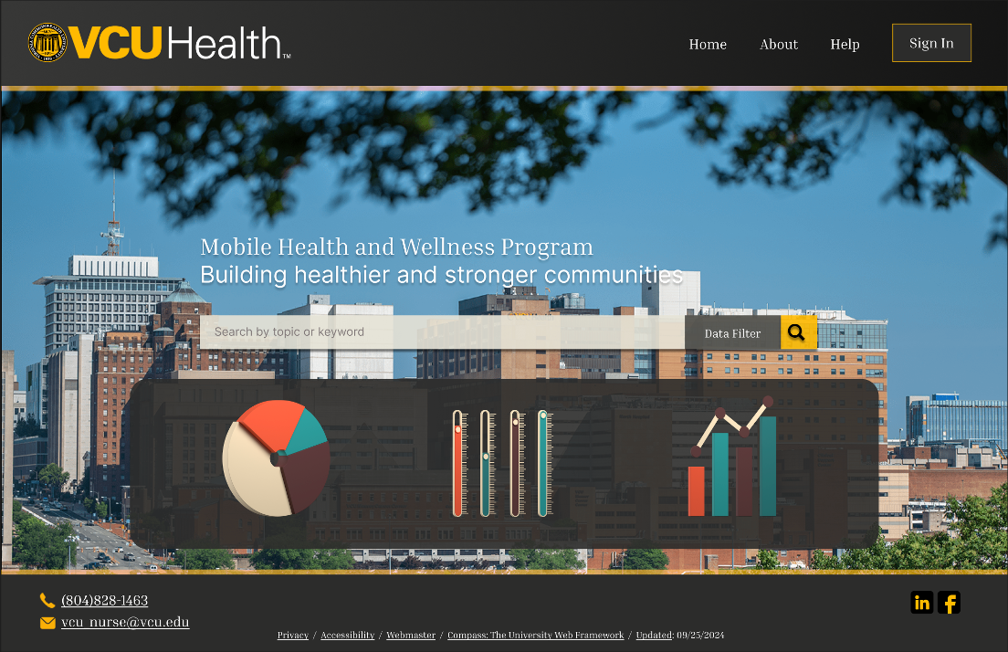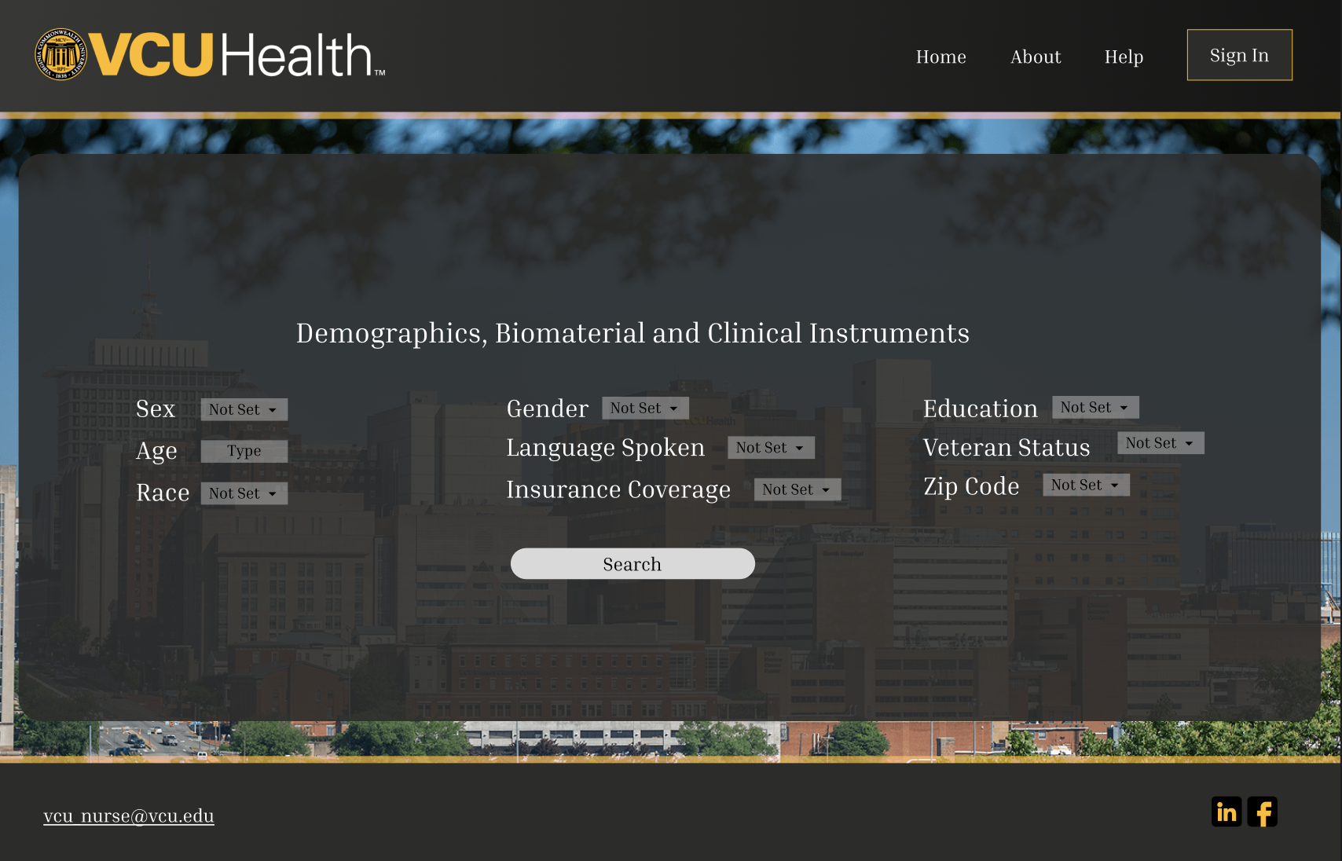

Below is an example of documenting sponsor feedback and editing workflow:  
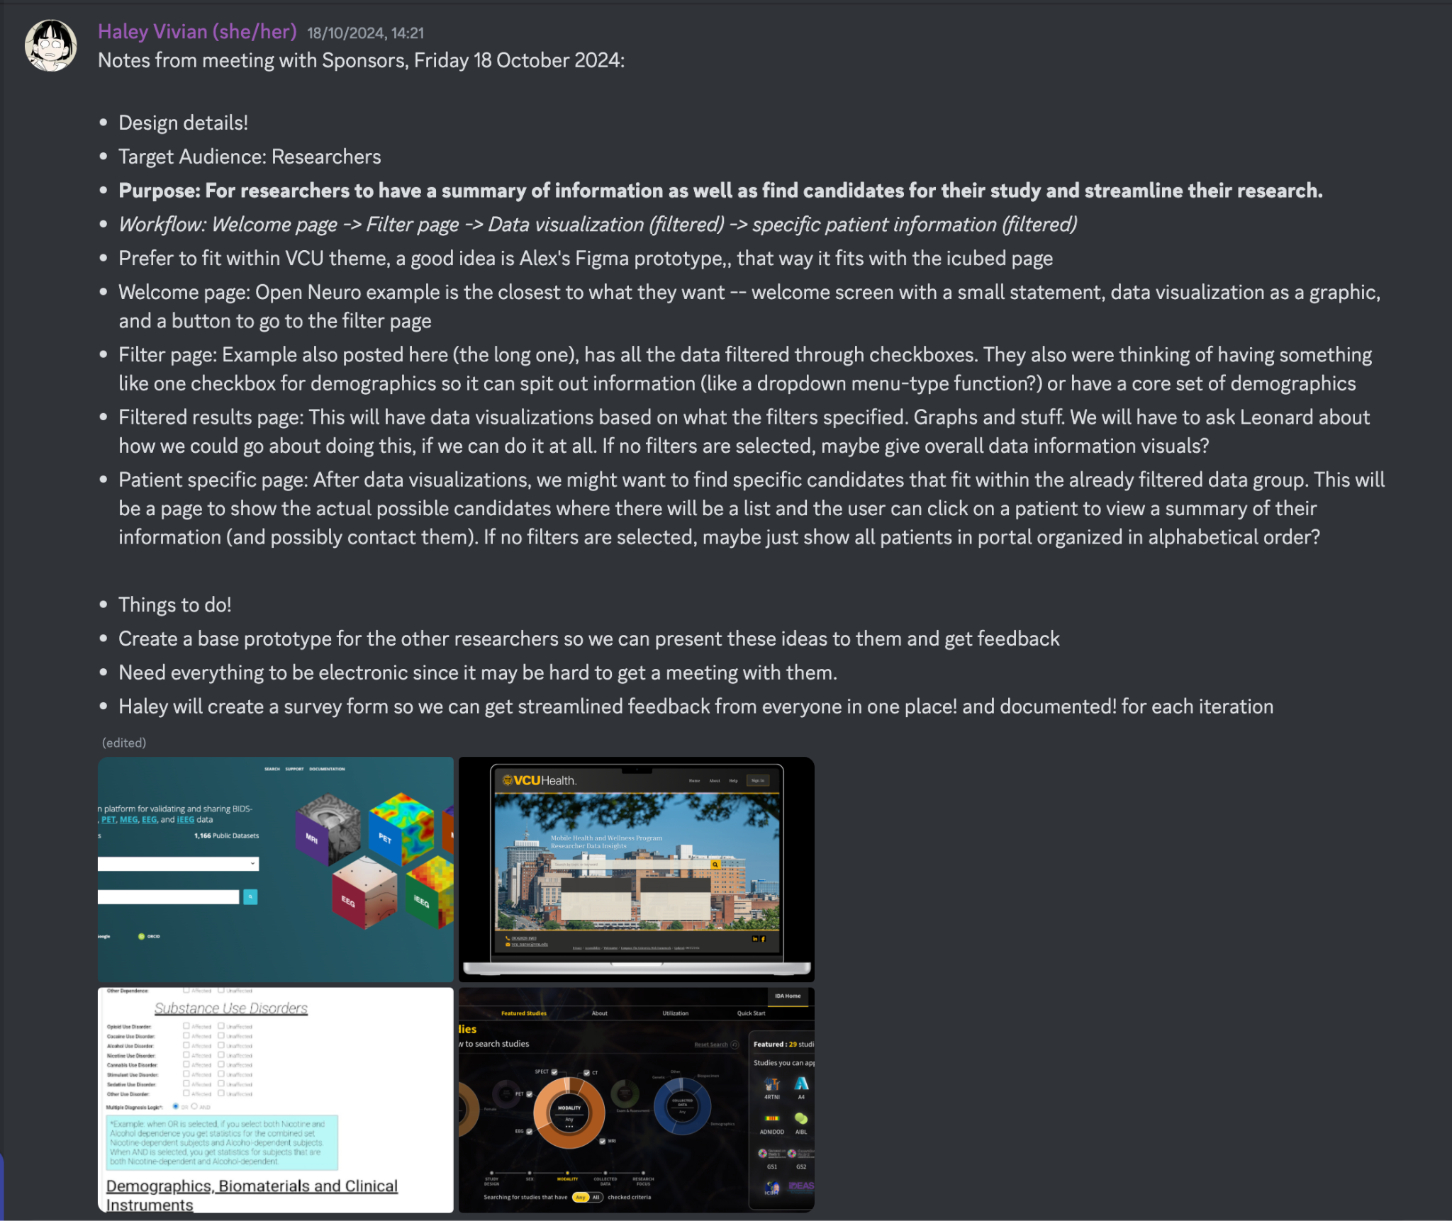

Below is the Final MVP design:

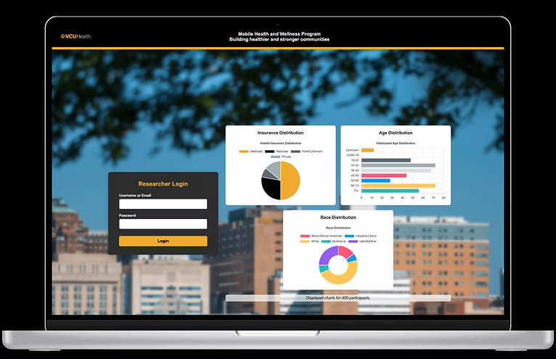

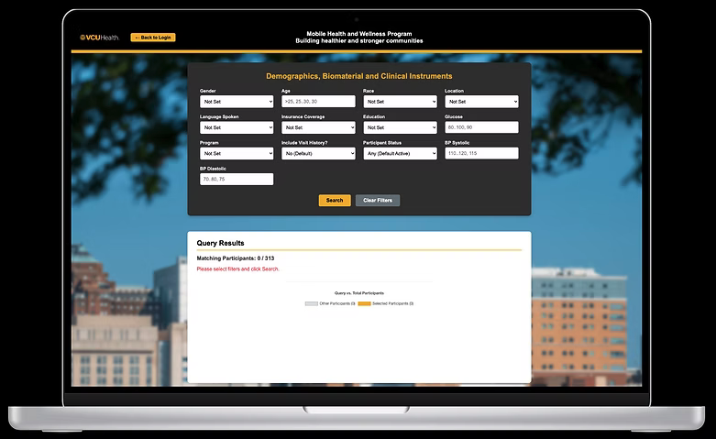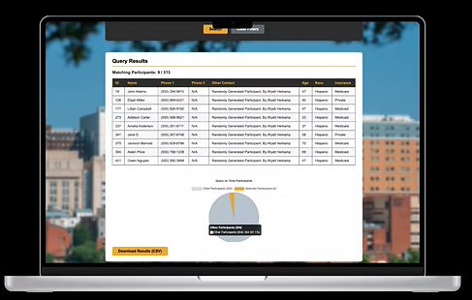

#### F.2 Computational and Analytical Methods

The computational methods used in this project play a crucial role in evaluating and refining the design. To ensure data integrity and scalability, the database design will undergo validation using test queries and sample data sets. The database, being developed using SQLite, adheres to normalization principles to ensure efficiency.

For the backend API, Flask will be used to handle requests and responses. We will validate endpoint functionality by simulating realistic user interactions. Mock datasets will be utilized to evaluate the reliability of data handling under various scenarios.

Our choice of SQLite and Flask reflects a balance between rapid development and scalability. These technologies facilitate testing for performance bottlenecks and provide a foundation for iterative improvements as the system evolves.

#### F.3 Experimental and Usability Testing

The MVP has undergone usability testing, where stakeholders provided feedback via live meeting and structured surveys. Key areas of focus included the clarity of workflows, ease of navigation, and alignment with user expectations. Feedback from sponsors and the participating researchers has been instrumental in refining the interface design.

Our primary goal is to ensure the application meets stakeholders’ needs by enabling seamless exploration of study participant data. Usability testing aligns with this objective, focusing on user-centered design principles.

Once backend components are implemented, usability testing will expand to include live interaction with the database and API. Planned tests include:

* Functionality Testing: Ensuring workflows operate as expected.
* Performance Testing: Evaluating response times under various load conditions.
* Edge Case Handling: Testing uncommon but plausible user actions.

#### F.4 Architecture and High-Level Design

The system architecture consists of three main components:

1. Website: The primary user interface, enabling researchers to explore participant data interactively.
2. Backend API: Acts as the intermediary between the application and the database, handling data requests and responses.
3. Database: Stores structured data from the MHWP repository, designed for efficiency and scalability.

Design assumptions include user familiarity with database interfaces and a moderate level of technical proficiency among researchers. These assumptions informed choices around interface simplicity and workflow prioritization.

#### F.5 Timeline for Development

The project follows an iterative timeline, divided into key phases:

1. Design Phase (Completed): Initial meetings, Figma prototype development, and stakeholder feedback.
2. Backend Development (Completed): Implementation of the database and API components.
3. Integration and Testing (Completed): Combining the frontend and backend, followed by usability and performance testing.
4. Deployment and Validation (Completed): Delivering the final system for stakeholder review and validation.

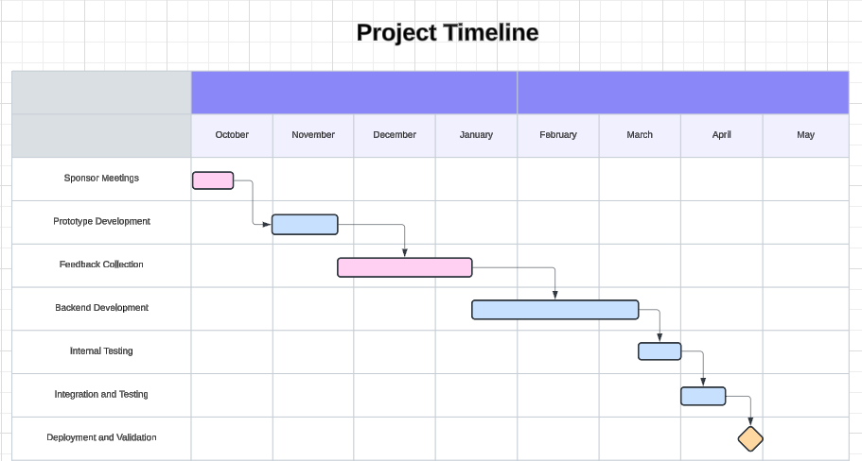

#### F.6 Validation Procedure

The final design will undergo a structured validation process to ensure it meets client needs and fulfills the outlined objectives. This will begin with a demonstration of the functional prototype, including the website and backend integration, scheduled for early April 2025. Stakeholders will provide feedback through surveys, interviews, and observational notes.

This feedback will be incorporated into the final iteration to address any remaining issues and ensure satisfaction. Additional validation will include functional testing of workflows, performance evaluations under simulated conditions, and tests to handle edge cases effectively.

### Section G. Results and Design Details

Use this section to highlight the major results of the design methodology described above including important analytical, computational, experimental, modeling, assembly, and testing results. This section should be one of the most substantial sections of the report showcasing all of the hard work and effort that went into the completion of the final design and delivery of the project deliverables. Show how the identified problem was solved.

Highlight the prominent features of the final design through analysis results, modeling, drawings, renderings, circuit schematics, instrumentation diagrams, flow and piping diagrams, etc. to show that the design functions as intended and meets all design objectives and constraints. Overview designs such as data flow diagrams, process flow, swim lane diagrams, as well as presentation-layer designs (e.g. storyboards for front-ends) should be included here. Detailed designs such as database designs, software designs, procedure flowcharts, or pseudocode should be included here. Support computational and experimental results with key plots and figures. All supporting figures should be clearly labeled and annotated to highlight the most important points of the figure (i.e. explicitly point out what the reader should focus on or understand about the image).

Note that while all results should be used to help inform design decisions, not all results may be necessary to include in the main body of the report. Extraneous supporting results (e.g. graphs, data, design renderings, drawings, etc.) that are not necessary for presenting the fundamental findings can be placed in one or more appendices. Detailed documentation of each program module can be provided as an appendix.

#### G.1 Modeling Results

• Models were developed to aggregate data from the MHWP RedCap framework and additional sources into a user-friendly format.

• Data modeling focused on ensuring accessibility for researchers, including filters for participant demographics, test results, and health trends.

• A prototype was created to visualize the application for seamless integration.

**Outputs:**

• Data flow diagrams illustrating how data moves from the RedCap framework to the API and tablet application.

• Entity-Relationship Diagram (ERD) showing database schema and relationships, emphasizing scalability and future integration with external tools.

#### G.2 Experimental Results

**Description:**

• Conducted simulations to test the API’s ability to handle large data queries efficiently and accurately.

• Tested various filters to ensure researchers can refine search criteria (e.g., demographics, test results) without lag.

• **Outputs:**

• Performance benchmarks indicating API response times for different query sizes.

• Experimental validation confirming that the filtering system identifies participants meeting specific criteria (e.g., high blood pressure).

#### G.3 Prototyping and Testing Results

**Description:**

• A prototype of the application was developed using figma for visualization.

• Focused testing on the look and functionality to ensure it supports research objectives.

**Outputs:**

• Storyboards of the tablet application showing key user flows, such as searching for participants and viewing aggregated results.

#### G.4. Final Design Details/Specifications

**Description:**

• The final design emphasizes a robust, secure API and a lightweight minimal application that supports aggregate data analysis and individual participant searches.

• The system meets design objectives by providing researchers with the ability to:

• Access aggregate demographic and test result data.

• Visualize historical health trends within the MHWP dataset.

**Specifications:**

• **API:** Secure, scalable, and capable of handling high query volumes.

• **Database:** Structured to connect RedCap data with additional sources, ensuring compliance with consent requirements.

• **Output Examples:** Search filters, participant data visualizations, and cohort summaries.

Note that while the design constraints and specifications may have provided minimum or maximum values, or ranges or values, that the design needed to meet, the final design specifications should be listed here showing that the required design values were met. A list of final design details can also be included to demonstrate fulfillment of the design objectives.

### Section H. Societal Impacts of Design

In addition to technical design considerations, contemporary engineers must consider the broader impacts that their design choices have on the world around them. These impacts include the consideration of public health, safety, and welfare as well as the potential societal, political/regulatory, economic, environmental, global, and ethical impacts of the design. As appropriate for the project design, discuss how each of these considerations influenced design choices in separate subsections. How will the design change the way people interact with each other? What are the political implications of the design? Does the technology have the potential to impact or shift markets? Does the design have any positive or negative effects on the environment? Don’t forget to consider unintended consequences such as process or manufacturing byproducts. What impacts might the design have on global markets and trade? Are there any ethical questions related to the design?

While it is hard to forecast the various impacts of a technology, it is important to consider these potential impacts throughout the engineering design process. When considered during the early stages of the design phase, consideration of these impacts can help determine design objectives, constraints, and specifications and help drive design choices that may mitigate any potential negative impacts or unintended consequences.

#### H.1 Public Health, Safety, and Welfare

Our project has a potential for a significant positive impact on the public health, safety, and welfare of the people of Richmond.

**Possible Effects on Public Health, Safety, and Welfare:**

* **Public Health:** Researchers will have greater access to high quality data. By providing researchers with higher quality information, this could lead to improvements in public health policy, disease fighting strategies, and approaches to treating illness.
* **Safety:** By consolidating disjoint and obtuse data into a single reliable, up-to-date source of health information, our web page will help minimize errors due to outdated or incomplete data, improving the overall safety of research findings.
* **Welfare:** When researchers' abilities are enhanced by high quality data, it could lead to innovations in healthcare. This can ultimately benefit the public by promoting better access to healthcare solutions and improving health outcomes.

#### H.2 Societal Impacts

#### As is stated above, by consolidating disjoint and obscure information into a single highly searchable database, we enhance the ability of health researchers to conduct important research improving healthcare practices, policies, and overall public health strategies. By empowering researchers to better track health information in the city of Richmond, we have the potential to improve the quality of life of all people, improving the impact healthcare has on their lives, contributing positively to their social welfare, and improving society as a whole.

#### H.3. Economic Impacts

#### This project has a variety of possible economic impacts. First, it could help lower research costs by providing researchers with a single, easily searchable database with highly discoverable data. After all, data collection can be quite expensive. Also, this database could empower researchers to make innovative new healthcare discoveries, which could potentially spur economic growth thanks to new health developments, treatments, or technologies. Through improving the cost efficiency of research and potentially leading to innovative healthcare discoveries, this database could potentially positively impact the economy.

#### H.4. Ethical Considerations

This database may contain sensitive health information, so there are many ethical considerations to take place. Most of the ethical considerations take place at the data-collection level, and are not actually handled by our team. However, our team must take care to protect the medical data on our webpage. The primary concern is data privacy. Data privacy must be protected by a login system where personal level individual data is only accessible by researchers, verified by login. By utilizing a log-in system to verify a researcher’s identity, personal medical data can be protected.

### Section I. Cost Analysis

Provide a simple cost analysis of the project that includes a list of all expenditures related to the project. If an experimental test set-up or prototype was developed, provide a Bill of Materials that includes part numbers, vendor names, unit costs, quantity, total costs, delivery times, dates received, etc. Do not forget to include all manufacturing costs incurred throughout the completion of the project. If the design is expected to become a commercial product, provide a production cost estimate including fixed capital, raw materials, manufacturing (including tooling and/or casting), and labor costs to produce and package the device. Note that this type of detailed cost analysis may be listed as a project deliverable.

**Note:** The Preliminary Design Report should include all costs incurred to date. It is expected that this section will be expanded and updated between the preliminary and final design reports.

No costs have been incurred while working on this project.

### Section J. Conclusions and Recommendations

Use this section to summarize the story of how the design team arrived at the final design. Focus on the evolution of the design through the use of the engineering design process including lessons learned, obstacles overcome, and triumphs of the final design. Revisit the primary project goals and objectives. Provide a brief summary of the final design details and features paramount to the function of the design in meeting these goals and objectives.

A discussion may be included to discuss how the design could be further advanced or improved in the future. If applicable, summarize any questions or curiosities that the final results/design of this effort bring to mind or leave unanswered. If this project might continue on as a future (continuation) senior design project, detail the major milestones that have been completed to date and include any suggested testing plans, relevant machine drawings, electrical schematics, developed computer code, etc. All relevant information should be included in this section such that future researchers could pick up the project and advance the work in as seamless a manner as possible. Documents such as drawings, schematics, and codes could be referenced here and included in one or more appendices. If digital files are critical for future work, they should be saved on a thumb drive, external hard drive, cloud, etc. and left in the hands of the project advisor and/or client.

We began the project by meeting with the faculty advisor to understand the basic specifications of the project, as well as gain valuable information on how to approach our sponsors while we work with them on this iterative process. We then moved forward and met with the sponsors and had a discussion about the MWHP itself and its mission, who the site’s target audience is, and what basic issues they wanted to address through the project – the core purpose of the website itself. Once we were able to discern exactly what the sponsors were aiming to achieve, we then were given the idea to come up with a Database Compilation document by our faculty mentor. This worked as a compilation of images, or examples, of different database interfaces that we presented to the sponsors to gain a more detailed view of specific design elements they wanted to see. This included details such as whether or not they wanted a search bar, what diagrams or figures they wanted to see, if any, or what kind of theming they preferred. As we worked through these details, we were able to develop a Figma prototype that reflected their preferences.

This prototype is described and depicted below:

This prototype design includes both a search bar and an option to filter through information, a menu on the top with a home, about, and help page, as well as a sign in option. The theme sticks to a typical VCU website, and is aimed to mesh well with other common VCU interface designs. There are also data visualizations included on the front of the website to reflect the researchers data within the database. Within the filter page, we included certain attributes that were specified by the sponsors, such as sex, age, race, and other important information such as diagnoses.

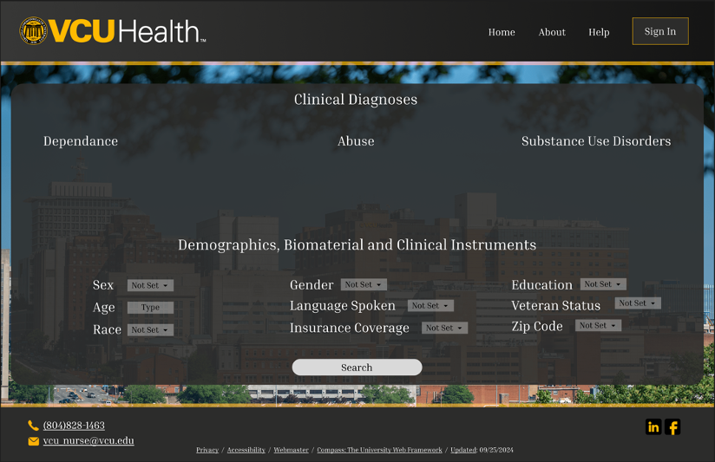

After developing the basic prototype, we then created a survey for the sponsors and stakeholders. We had an issue with getting everyone together for one meeting – as most people had busy schedules – so to work around it we came up with the idea to make a survey. This survey allowed sponsors, the advisor, and the stakeholders to remotely see the prototype and provide detailed, documented feedback, as well as look at other examples to further fine tune the design for the optimal workflow.

This semester’s work was singularly focused on turning that prototype into a working MVP. We hand-coded the front end in HTML, CSS, and JavaScript; containerized the UI, API, and SQLite database with Docker Compose; and integrated the RedCap-parsing back end delivered by our partner Capstone team. The outcome is a fully functional web application that supports live participant search and multi-criteria filtering directly against real data, exactly as scoped.

While the MVP satisfies all original objectives, it also lays a clear foundation for future enhancements—such as more advanced interactive visualizations and richer analytics dashboards.





### Appendix 1: Project Timeline

Provide a Gantt chart of similarly composed visual timeline showing the start and end dates of all completed tasks and how they are grouped together, overlapped, and linked together. Include all senior design requirements including design reports and Expo materials (i.e. Abstract, Poster, and Presentation). All major milestones should be included in the timeline.



### Appendix 2: Team Contract (i.e. Team Organization)

# Step 1: Get to Know One Another. Gather Basic Information.

**Task:** This initial time together is important to form a strong team dynamic and get to know each other more as people outside of class time. Consider ways to develop positive working relationships with others, while remaining open and personal. Learn each other’s strengths and discuss good/bad team experiences. This is also a good opportunity to start to better understand each other’s communication and working styles.

|  |  |  |  |
| --- | --- | --- | --- |
| ***Team Member Name*** | ***Strengths each member bring to the group*** | ***Other Info*** | ***Contact Info*** |
| William Meredith | *Backend design*  *Leadership*  *Project design* | *Good communication skills, willing to work with anyone regardless of skill level* | *meredithw@vcu.edu*  *wgmeredith@outlook.com* |
| *Haley Vivian* | *Design*  *Documenting*  *Writing*  *Illustration Organization* | *Some basic experience with Figma, Quarto. Good communication skills, organized, open-minded.* | vivianhe@vcu.edu  haleyvivian16@gmail.com |
| *Edson Decker* | *Coding*  *Design*  *Writing*  *Illustration* | *Some experience with a variety of programming languages. Good communicator. Proactive attitude.* | deckere2@vcu.edu |
| *Alex Davidkov* | *Design*  *Documenting*  *Illustrations* | *Good communication skills, Detailed oriented, experience with Figma.* | davidkovak@vcu.edu  alexdavidkov3@gmail.com |

|  |  |  |
| --- | --- | --- |
| ***Other Stakeholders*** | ***Notes*** | ***Contact Info*** |
| *Faculty Advisor: John Leonard* | *Meets with the students on the project and will give advice on how to proceed and how to interpret the wants from the sponsor.* | jdleonard@vcu.edu |
| *Project Sponsor: Dr. Lana Sargent* | *Will provide the framework for use in implementation of project and convey what is needed from the students* | lsargent@vcu.edu |

# Step 2: Team Culture. Clarify the Group’s Purpose and Culture Goals.

**Task:** Discuss how each team member wants to be treated to encourage them to make valuable contributions to the group and how each team member would like to feel recognized for their efforts. Discuss how the team will foster an environment where each team member feels they are accountable for their actions and the way they contribute to the project. These are your Culture Goals (left column). How do the students demonstrate these culture goals? These are your Actions (middle column). Finally, how do students deviate from the team’s culture goals? What are ways that other team members can notice when that culture goal is no longer being honored in team dynamics? These are your Warning Signs (right column).

|  |  |  |
| --- | --- | --- |
| ***Culture Goals*** | ***Actions*** | ***Warning Signs*** |
| *Being on time for every meeting.* | - *Set up meetings in shared Discord*    - *Send a reminder message aday before the meeting.* | - *Student misses first meeting, warning is granted*    - *Student misses meetings afterward – the issue is brought up with the faculty advisor* |
| *Informing the group of any delays in completing assignments.* | - *Stay up to date with each other’s project responsibilities*    - *Set reasonable deadlines and note when an extension is needed* | - *Student shows up for weekly meeting with no considerable work don*e |
| *Respecting each team member’s abilities and supporting each other in a positive way* | - *Expectations of communicating when struggling*    - *Staying professional, mindful of words and actions to other team members* | *- Project members have a severe lack of communication and not working together with other group members*    *- Project member seems agitated with others’ abilities, can bring this up to faculty members and other group members to get them back on track* |

# Step 3: Time Commitments, Meeting Structure, and Communication

**Task:** Discuss the anticipated time commitments for the group project. Consider the following questions (don’t answer these questions in the box below):

● What are reasonable time commitments for everyone to invest in this project?

● What other activities and commitments do group members have in their lives?

● How will we communicate with each other?

● When will we meet as a team? Where will we meet? How Often?

● Who will run the meetings? Will there be an assigned team leader or scribe? Does that position rotate or will same person take on that role for the duration of the project?

**Required:** How often you will meet with your faculty advisor advisor, where you will meet, and how the meetings will be conducted. Who arranges these meetings?

See examples below.

|  |  |  |
| --- | --- | --- |
| ***Meeting Participants*** | ***Frequency***  ***Dates and Times / Locations*** | ***Meeting Goals***  ***Responsible Party*** |
| *Students Only* | *Frequency: Once a week*  *Time: Thursday evenings*  *Location: Over Zoom or Discord* | *Check-in/progress update, discuss weekly goals, aid in struggle points (Haley will take notes of all meetings)* |
| *Students + Faculty advisor* | *Frequency: Once a week Time: Thursday evenings*  *Location: Zoom* | *Help understand the requirements of the project sponsor and give suggestions and ways of implementing said requirements, give general background knowledge on the project (Haley will take notes of all meetings)* |
| *Project Sponsor* | *Frequency: Once a month / irregularly, whenever needed*  *Time: As needed*  *Location: Zoom* | *Regular updates on progress and presentation of prototypes*  *Get an understanding of what the deliverables are and what the departments need (Haley will take notes of all meetings)* |

**Step 4: Determine Individual Roles and Responsibilities**

**Task:** As part of the Capstone Team experience, each member will take on a leadership role, ***in addition to*** contributing to the overall weekly action items for the project. Some common leadership roles for Capstone projects are listed below. Other roles may be assigned with approval of your faculty advisor as deemed fit for the project. For the entirety of the project, you should communicate progress to your advisor specifically with regard to your role.

● **Before meeting with your team**, take some time to ask yourself: what is my “natural” role in this group (strengths)? How can I use this experience to help me grow and develop more?

● **As a group,** discuss the various tasks needed for the project and role preferences. Then assign roles in the table on the next page. Try to create a team dynamic that is fair and equitable, while promoting the strengths of each member.

**Communication Leaders**

**Suggested:** Assign a team member to be the primary contact for the client/sponsor. This person will schedule meetings, send updates, and ensure deliverables are met.

**Suggested:** Assign a team member to be the primary contact for faculty advisor. This person will schedule meetings, send updates, and ensure deliverables are met.

**Common Leadership Roles for Capstone**

1. **Project Manager:** Manages all tasks; develops overall schedule for project; writes agendas and runs meetings; reviews and monitors individual action items; creates an environment where team members are respected, take risks and feel safe expressing their ideas.

**Required:** On Edusourced, under the Team tab, make sure that this student is assigned the Project Manager role. This is required so that Capstone program staff can easily identify a single contact person, especially for items like Purchasing and Receiving project supplies.

1. **Logistics Manager:** coordinates all internal and external interactions; lead in establishing contact within and outside of organization, following up on communication of commitments, obtaining information for the team; documents meeting minutes; manages facility and resource usage.
2. **Financial Manager:** researches/benchmarks technical purchases and acquisitions; conducts pricing analysis and budget justifications on proposed purchases; carries out team purchase requests; monitors team budget.
3. **Systems Engineer:** analyzes Client initial design specification and leads establishment of product specifications; monitors, coordinates and manages integration of sub-systems in the prototype; develops and recommends system architecture and manages product interfaces.
4. **Test Engineer:** oversees experimental design, test plan, procedures and data analysis; acquires data acquisition equipment and any necessary software; establishes test protocols and schedules; oversees statistical analysis of results; leads presentation of experimental finding and resulting recommendations.
5. **Manufacturing Engineer:** coordinates all fabrication required to meet final prototype requirements; oversees that all engineering drawings meet the requirements of machine shop or vendor; reviews designs to ensure design for manufacturing; determines realistic timing for fabrication and quality; develops schedule for all manufacturing.

|  |  |  |
| --- | --- | --- |
| ***Team Member*** | ***Role(s)*** | ***Responsibilities*** |
| *William Meredith* | *- Database Leader*  *- Backend Developer - Test Engineer* | *- Develop an understanding of the RedCap database and work with other students/project members to make sure all elements of our project can interact with the required data.*  *- Implement back-end design for project*  *- Establish test protocols and schedules, oversee experimental design* |
| *Alex Davidkov* | *-Design front-end*    *-Illustrations*    *-Test Engineer* | - *Design the front-end look of the web application.*    - *Create any illustrations needed for the application.*    - *Test application as needed.* |
| *Edson Decker* | *- Systems Engineer*  *- Test engineer* | *Interpretes client specifications and establishes product requirements. Coordinates integration of subsystems in prototype. Oversees experimental design, test plan, procedures and data analysis. Oversees statistical analysis of results.* |
| *Haley Vivian* | *- Logistics Manager*  *- Test Engineer*  *- Financial Manager* | *Coordinate all internal and external interactions, following up on communication of commitments, obtaining information for the team; documents meeting minutes*    *Conducts pricing analysis and budget justifications on proposed purchases; carries out team purchase requests; monitors team budget*  *Oversees experimental design, test plan, procedures and data analysis; establishes test protocols and schedules* |

# Step 5: Agree to the above team contract

*Team Member: Alex Davidkov Signature: Alex Davidkov*

*Team Member: William Meredith Signature: William Meredith*

*Team Member: Edson Decker Signature: Edson Decker*

*Team Member: Haley Vivian Signature: Haley Vivian*

### References

Provide a numbered list of all references in order of appearance using APA citation format. The reference page should begin on a new page as shown here.

[1] VCU Writing Center. (2021, September 8). *APA Citation: A guide to formatting in APA style.* Retrieved September 2, 2024. https://writing.vcu.edu/student-resources/apa-citations/

[2] Teach Engineering. *Engineering Design Process*. TeachEngineering.org. Retrieved September 2, 2024. https://www.teachengineering.org/populartopics/designprocess